**Lab 6**

**Exercise 8.3 Part 1** (Student Poll App) Figure 7.4 contains an array of survey responses that’s hard-coded into the app. Suppose we wish to process survey responses to a file. First, create an app that enables the user to write survey responses to a file. Use a **StreamWriter** to create to a file called **SurveyResponses.txt** and write each response on a separate line. Your Lab 5 is a good coding example. Add your own comments in your code. See the complete app example in the lab folder.

**Initial Interface: Insert your name in the Form’s title property.**

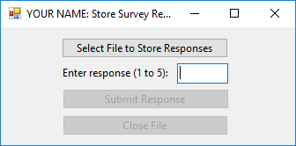

**Interface after creating a file**

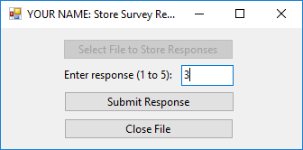

**Control Names**

|  |  |
| --- | --- |
| selectFileButton | responseTextBox |
| submitResponseButton | closeFileButton |

**What to turn in:**

1. Make sure that your project folder (i.e., lab06) has all the files you have worked on.
2. Zip your working folder (i.e., lab06) by right-clicking the folder and selecting Send to > Compressed (zipped) folder in the context menu.
3. Give the zip file an appropriate name (e.g., lab06end.zip).
4. Submit the zip file through the Dropbox in D2L.

**HW 1**

**Exercise 8.3 Part 2** (Student Poll App) Modify the code in Fig 7.4 to read the survey responses from SurveyResponses.txt by using a StreamReader. The app should continue to read responses until it reaches the end of file. Your Lab 5 is a good coding example using a StreamReader. Add your own comments in your code.

**Design your interface: Insert your name in the Form’s title property and give your controls proper names.**

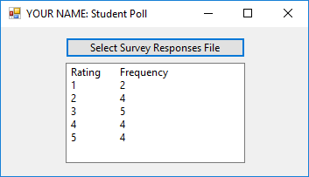

**What to turn in:**

1. Make sure that your project folder (e.g., hw01) has all the files you have worked on.
2. Zip your working folder by right-clicking the folder and selecting Send to > Compressed (zipped) folder in the context menu.
3. Give the zip file an appropriate name (e.g., hw01end.zip).
4. Submit the zip file through the Dropbox in D2L.